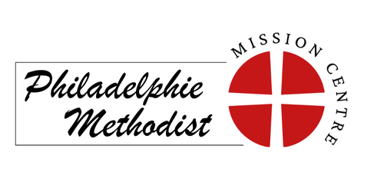
Enquiry form for hire of
Philadelphie Methodist Centre

Full name of person enquiring:
Organsation name (if appl.):
Email:
Telephone number:
Details of event type:
(Please note that no alcohol is allowed on the premises or car park)
How many people do you expect at the event:
Is this a recurring event or one off:
Date/s of event:
Times you wish to have the space available:
(Please include sufficient time for preparation and clearing up within your hire times)
Please circle the main space you are interested in hiring:

Worship Space / Church Hall / Both

Will you require use of the kitchen facilities: Yes / No

If you have any additional questions or details about the event you are intending to hire for, please add here:

Please ensure this form is completed as fully as possible and send to circuit.office.jsy@gmail.com, so that confirmation of availability and notice of the cost of hire can be provided.

