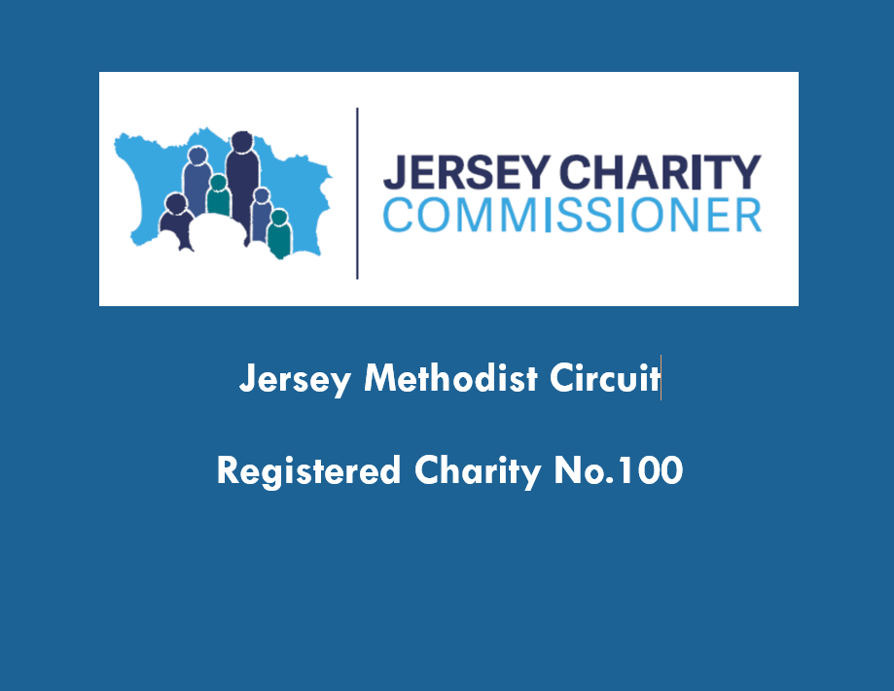

NOTES FOR MINISTERS CONSIDERING A MOVE TO JERSEY
www.jerseymethodist.org.uk
Thank you for your interest in a stationing opportunity in Jersey. The Circuit Stewards are confident in recommending Jersey as an attractive, outward-looking and friendly place to live and work, with a well-developed sense of community and heritage.
We trust these notes will answer any questions you may have about the uniqueness of Jersey and how living here differs from the United Kingdom. Depending upon your own personal and family circumstances, there may be a need to undertake further enquiries and/or take advice in order to fully understand the differences. We will be delighted to assist if you require further information to decide whether or not a move to Jersey is appropriate for you and your family but, above all, whether it is God’s calling to you at this time.
The Island of Jersey
The Island is self-governing and a Crown Territory. It is approximately 45 square miles and is basically a rectangle of 9 miles by 5 miles. It is 14 miles from the north coast of France, at the nearest point, and about 100 miles south of Portsmouth. Guernsey and Sark are the closest of the other Channel Islands and are 20 or so miles to the northwest. Jersey has many lovely sandy beaches and is home to the world famous Jersey cow and the Jersey Royal new potato.
Jersey has its own government and is autonomous in local matters with its own tax, social security/national insurance and other regulations which differ from the UK. Jersey is made up of 12 Parishes varying in size and population from the capital, St Helier, to the smallest (by population) St Mary. The Parishes have their own administrations and provide a number of services including local policing (the Honorary Police), issuing driving licences, electoral registration etc. The population is circa 108,000 (2019 estimate; Census figure for 2021 awaited) and is made up of locals and immigrants, the largest groups of which come from the UK, Ireland, Madeira and Poland.
The Church of England is the established church but the Catholic Church, Methodist Church and other church groups meet regularly in the Island.
There are 8 Methodist Churches with a total membership of c. 400. There are 5 full time presbyters and a number of part-time lay workers engaged by local churches. The Circuit employs a Circuit Safeguarding officer, a Circuit Administrator and a Circuit Treasurer. Further information is on the website www.jerseymethodist.co.uk. | 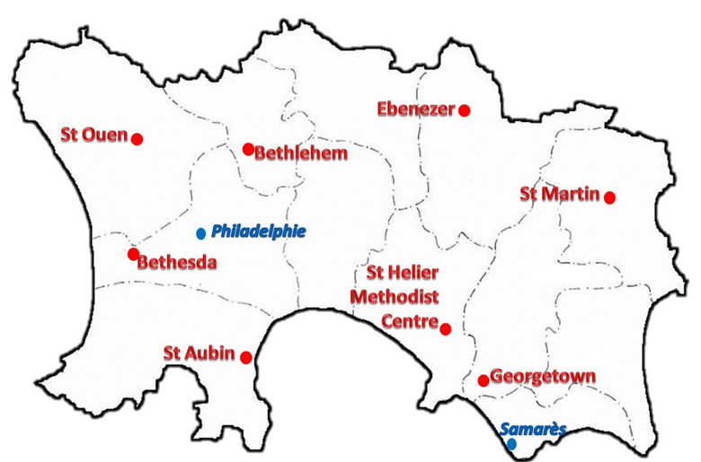
More information about the Island in general can be obtained from many local web sites including www.gov.je ; www.jersey.com and https://parish.gov.je.
Transport to and from Jersey
There are excellent air and sea links to and from Jersey. Services are more frequent in the summer months and prices vary but may be cheaper if booked in advance and outside school holiday periods. Occasionally services are affected by adverse weather conditions, in particular fog can cause flight delays or cancellations and rough seas can affect shipping links:
- air services are available daily throughout the year to many destinations in the UK and Europe; carriers currently include British Airways and Easyjet amongst others.
- sea links to the UK and France (fast ferry roll-on/off) are provided by Condor Ferries.
Accommodation and moving costs
A manse is provided as set out in Standing Orders and currently the relocation grant is set by Connexion at £600. All removal costs, including car(s) etc, are paid by the Circuit/Connexion. You will need to register your car in Jersey and also apply for Jersey driving licences – Minister’s costs are met by the Circuit (further details in ‘Motoring’ below).
When it comes to getting estimates for the move it is expected that you obtain three including one from an international firm such as Pickfords or Whites. It is essential to get all firms quoting to split the quotation so that the cost of the sea shipment, including marine insurance, is clearly identified as this part of the total cost is recoverable by the Circuit from Connexion. Should you already have household insurance arranged through Methodist Insurance this is likely to provide the marine – but please check!
Stipend
The Stipend is paid monthly in advance directly to a bank account of your choice. The rate is that set by Connexion but is adjusted upwards by a Jersey Allowance. Whilst there are many benefits from living on Jersey, it is generally acknowledged that some basic foodstuffs are more expensive than in the UK. There is currently no VAT but there is 5% Goods and Services Tax (GST) which applies to all goods including food.
All the main UK banks have branches in the Island and you may wish to open a local account – the banks have to meet strict KYC (Know Your Customer) requirements and you should allow sufficient time for this.
Social Security/National Insurance
Methodist Ministers in Jersey are regarded as self-employed and as such are responsible for the payment of the equivalent of both employer and employee Social Security contributions (NIC in UK terms). In an attempt to maintain a level playing field with colleagues in the UK, the Circuit makes a further contribution on all stipend payments. This can be paid directly into the Methodist Ministers’ Retirement Scheme by way of AVC with no tax implications or in cash or a mixture of the two. However any cash payment will be regarded as taxable income and will also impact upon the amount of Social Security contribution.
Jersey has its own Social Security; state pensions and benefits differ from those in the UK and you should refer to current information from the UK Department for Works and Pensions (see www.dwp.gov.uk/lifeevent/workage/) and from the Jersey Customer and Local Services Department (see www.gov.je). It is important to bring with you P60s for the previous 3 years so that the level of Social Security payment may be fixed on previous earnings. This also applies to a working spouse. The different financial year end dates can impact upon pension entitlements unless properly protected. Further details can be obtained both by telephone and from websites.
Family income supplement/allowances also differ in Jersey. There is no Child Tax Credit or Child Benefit, as in the UK, but there is ‘Income Support’ which is a means tested allowance but only available to persons who have been resident for 5 years. Further details are available from the Customer and Local Services Department in Jersey. The Circuit Stewards are alert to the potential financial disadvantage to a Minister with dependent child(ren) moving to Jersey because of the loss of Child Tax Credit and/or Child Benefit. We have alerted the Connexional Allowances Committee to this issue and wish to assure you that we are currently seeking a satisfactory solution; pending the outcome of this we make a payment equivalent to the UK child benefit. We do not wish this potential financial disadvantage to deter you from considering an invitation to Jersey if God is calling you here.
Income Tax
The tax year in Jersey is the calendar year. The Income Tax Instalment System (ITIS) rate is calculated from the registration information you provide. ITIS works on the current year basis and you can update the rate if your income changes to make sure you don't underpay. The tax is then finalised the following year when the return is submitted (any unpaid balance would need to be paid or a repayment would be due if the tax was overpaid).
It is important to note that the allowances are based on the period of residence in Jersey in weeks and the tax year is from January-December but, in line with Connexion, stipends are paid monthly in advance. It may be that a reduced/nil UK tax bill will be payable in the years of moving from and back to the UK, depending upon your personal circumstances.
Motoring
This section applies for an appointment of more than 12 months.
There is a potential vehicle importation tax to pay on cars. This is suspended if you have owned the car for at least 6 months and is conditional upon the car being retained for a further 12 months in Jersey. Vehicle registration with new number plates will be required and there will be a need to exchange UK driving licences for local driving licences from the Parish Hall (1 passport quality photo required; cost £50 for a 10 year licence – see ‘Accommodation and moving costs’ above). Further details available from www.gov.je
A mileage allowance is payable, see below.
Road tax was abolished in Jersey some years ago in favour of an additional tax on petrol/diesel. However, a ‘windscreen insurance disc’ (WID) is required as proof that the vehicle is insured and this is provided by the insurance company. Periodic inspections (similar to MOT) are being phased in for all vehicles.
Education
Jersey has good public funded and private schools, which take young people through to university stage (see www.gov.je). There also is a College for Further Education which has links to UK universities (see www.highlands.ac.uk). Student loan facilities are not available from Jersey but may be obtained from local banks through a scheme introduced by the Education Department to assist in meeting ‘top up’ fees imposed by UK universities. UK universities generally regard students from Jersey as “Islands Students” attracting higher fees. Grants, subject to means tests, are still the way the Island supports further education but there is a 5-year residency requirement. Connexional allowances may also be available.
Within the States (public funded) system, junior schools cover Reception to year 6, with Secondary education for years 7 – 11 provided at a further four schools. Some junior schools have nursery provision and there are also private nurseries. There is an optional 14+ transfer to Hautlieu School for GCSE and ‘A’ level courses. Students may also transfer at 16+ for ‘A’ levels.
Employment
Should a spouse wish to work during your time in Jersey it is acknowledged by the authorities that clergy and their family are regarded as permanent residents for employment purposes and can apply for any jobs irrespective of otherwise stated 5 year residential qualification requirements.
Pets
There are a few restrictions on the import of pets so it is worth checking with your vet and/or Customs and Excise. Information on importing pets and other small animals is also available on www.gov.je. Local legislation requires all dogs to be licensed and an annual permit must be purchased from the Parish Hall (cost £10 per dog) – see https://parish.gov.je (under ‘Licences’).
Expenses
The Circuit provides cover for the following expenses at currently agreed rates:
Telephone: The Circuit meets the cost of a telephone line rental and call costs for church purposes, Ministers contribute to call costs for private use. A broadband facility is also provided at Circuit cost. Telephone accounts are rendered by the local company on a monthly basis and paid by the Circuit by direct debit. On a quarterly basis, as part of the expenses claim, you are asked submit a copy account to notify the Circuit Treasurer of the cost of personal calls in the preceding quarter and this will be deducted from the payment of other expenses for that period.
Postage: A claim form is sent to all Ministers on a quarterly basis in order that postage incurred for the Circuit as a whole may be reclaimed. Postage in relation to the church(es) for which you are responsible should be claimed from the respective church treasurer.
Stationery: As for postage above (this includes printer ink etc). The Circuit has an account with Paperclix Ltd, a local stationer, through which items of stationery may be purchased and the account is sent monthly to the Circuit Treasurer (you should forward details of purchases with your quarterly expenses claim).
Medical Expenses: Medical cover differs from that available in the UK. The Health Insurance Scheme requires 6 months residence to qualify for benefit, so for the first 6 months, the Circuit meets all doctor’s and related costs (an introduction to a Doctor/General Practitioner can be made on your arrival). After 6 months, the Health Insurance Scheme provides a subsidy towards doctor’s charges and prescribed drugs on an approved list – the Circuit will reimburse the balance of the doctor’s charge and meet the cost of prescribed drugs not on the approved list. These costs are reimbursed by Connexion to the Circuit. Medical expenses are treated as an additional income by Income Tax and therefore ITIS is deducted from amounts paid by the Circuit to you; if payment is made direct to the supplier it may be a benefit in kind and tax is not deducted (there is a limit on the total value of benefits in kind that is exempt from tax, please refer to the Taxes Department for full details). Specialist treatment/surgery is available through the local hospital, on referral by a General Practitioner. Hospital treatment is free. Patients may be referred to the UK for tertiary treatment.
Dentists’ and Opticians’ services are not free in Jersey and the Circuit does not fund these costs. Some cover may be available through the hospital e.g. for younger children, and there is a Government contributory dental scheme (conditions apply – please refer to gov.je). It is strongly recommended that all treatment is up to date before leaving the mainland. A contribution may be considered towards dental treatment (but not cosmetic work) if the costs would cause financial hardship but only in the event that this is sought from the Circuit Stewards prior to treatment starting (it may be necessary to seek estimates from more than one dentist).
Travel Expenses: Connexional allowances are paid, the car mileage allowance is 45p per mile (20p per mile for bicycle) and is claimed each quarter. It is a requirement to maintain a log. Mileage is considered fully expended for tax purposes.
Travel costs for courses and meetings are normally dealt with on an ‘as and when’ basis, following approval by the Superintendent.
Holiday Travel: Connexion currently meets the cost of up to 2 personal/family visits to the UK each year.
We have made every effort to ensure that this information is accurate but it is only intended to draw attention to major differences and is in no way exhaustive. This paper is not a legal document and we apologise for any errors or omissions.
Should you have any questions which are not answered by this paper or the links provided please do contact the Circuit Stewards or Circuit Treasurer E: circuit.treasurer.jsy@gmail.com or Circuit Administrator T: 01534-730914 and we will endeavour to find the answer for you!

